**Jira**

**1.creating jira instance**

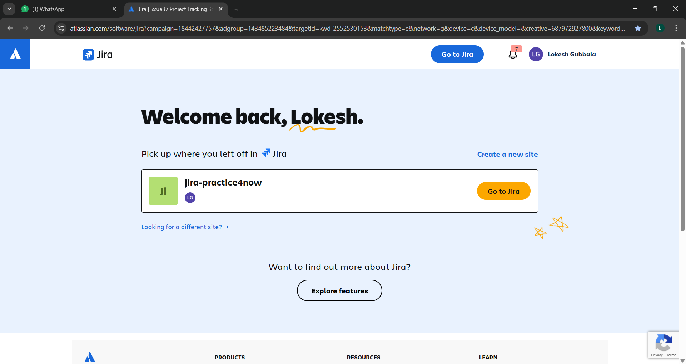

Go to google and search for Atlassian jira>create jira instance

**2.creating a project/space**

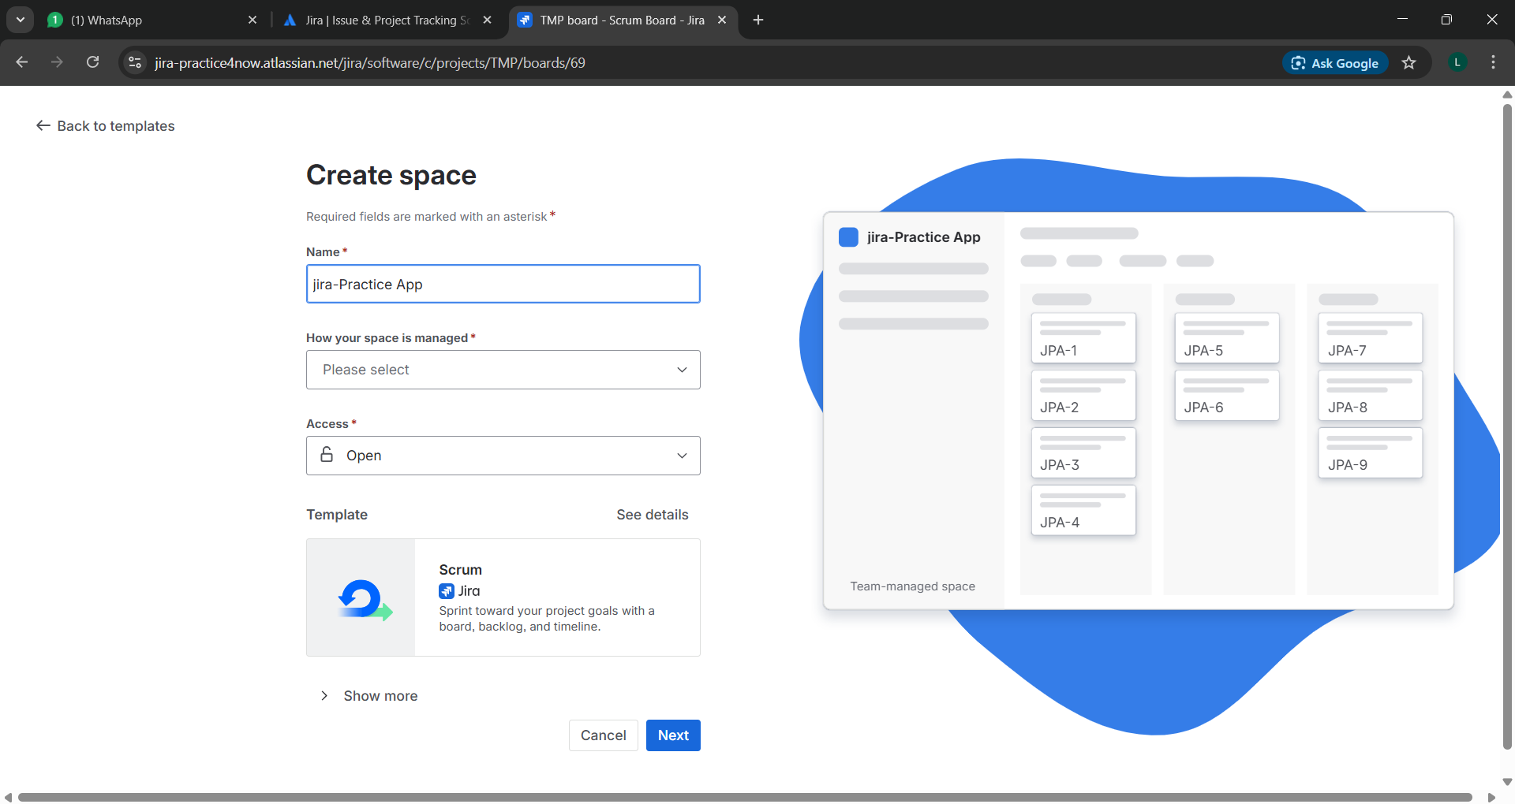

After creating a jira instance ,we can create a space which may be a team based space or company based space

*“space” is the term used for “project” in early version

Here team based have high customization scope where company based have control by the admin only.

**3.Work items /issues in jira by default**

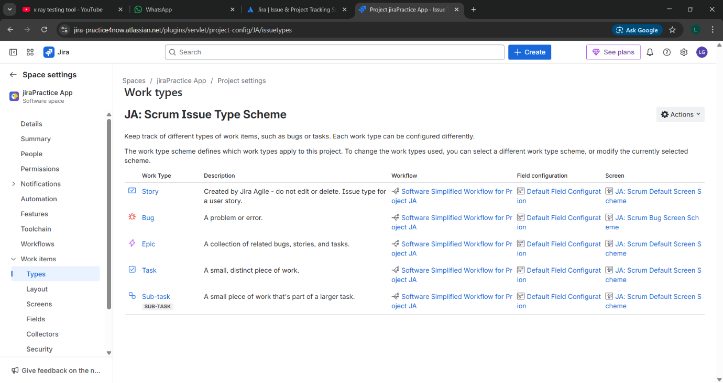

**4.Creating a story**

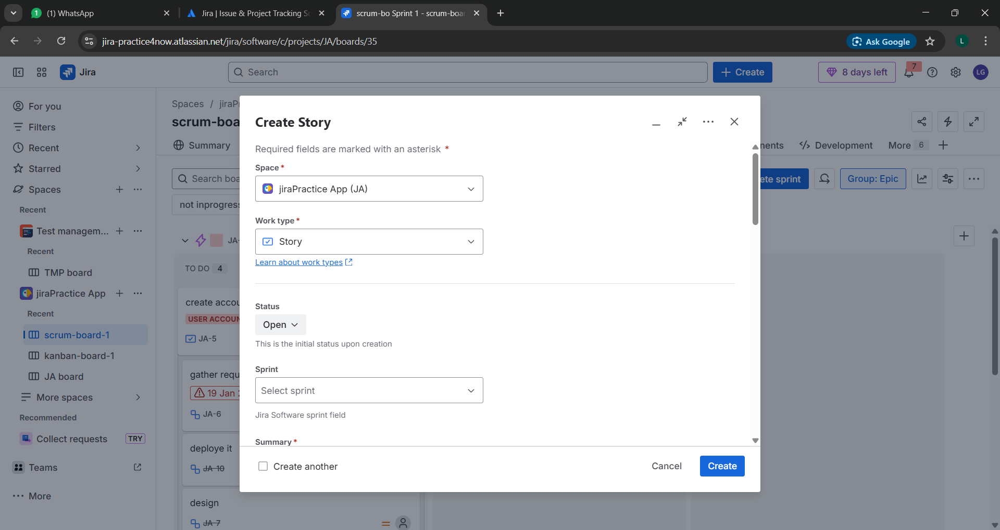

**5.Creating a subtask under a story**

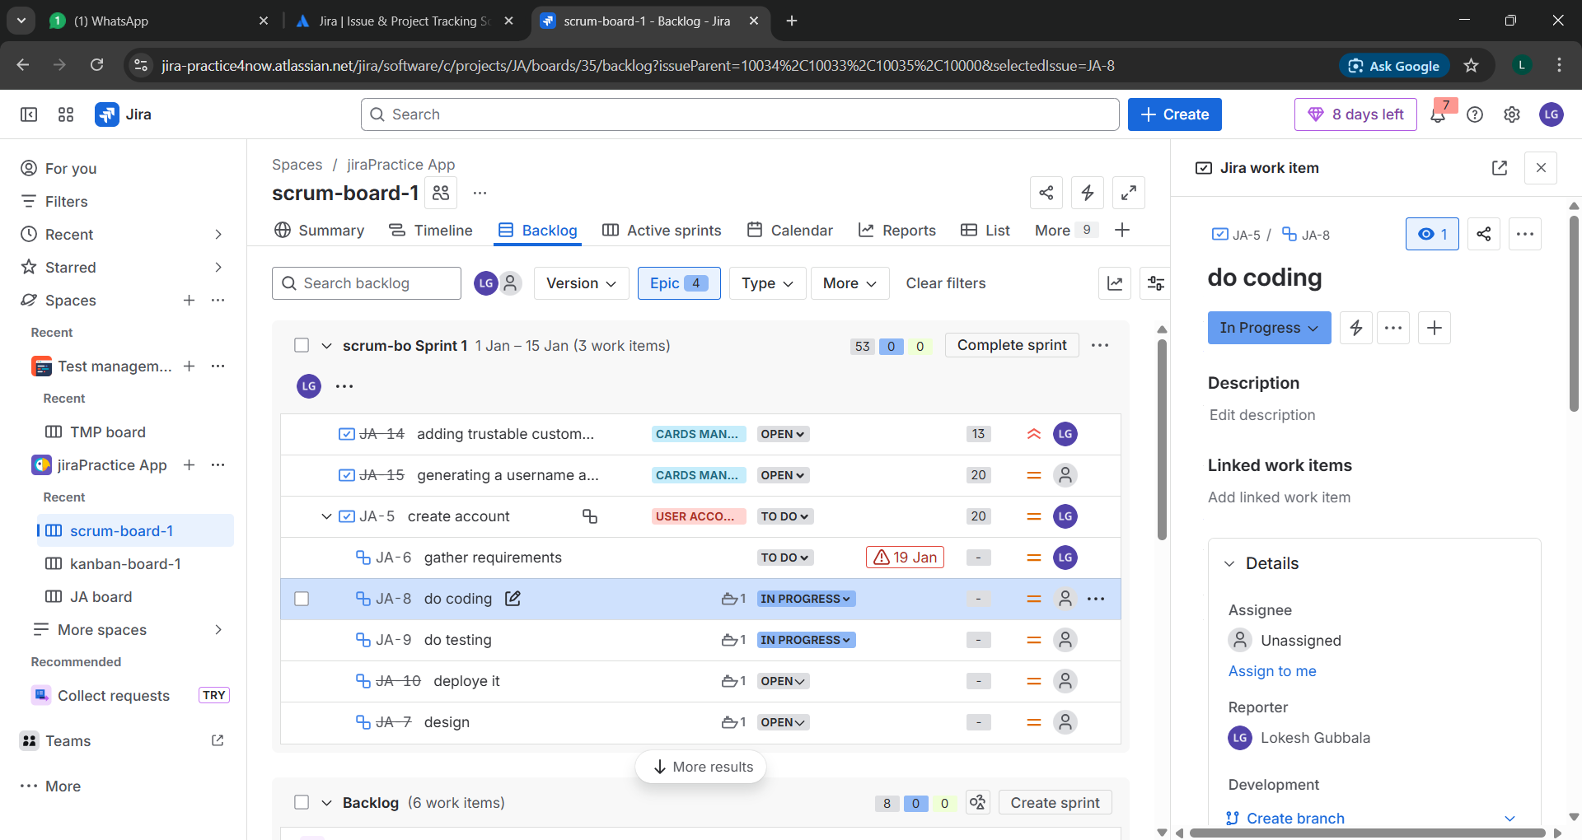

**6.creating an epic**

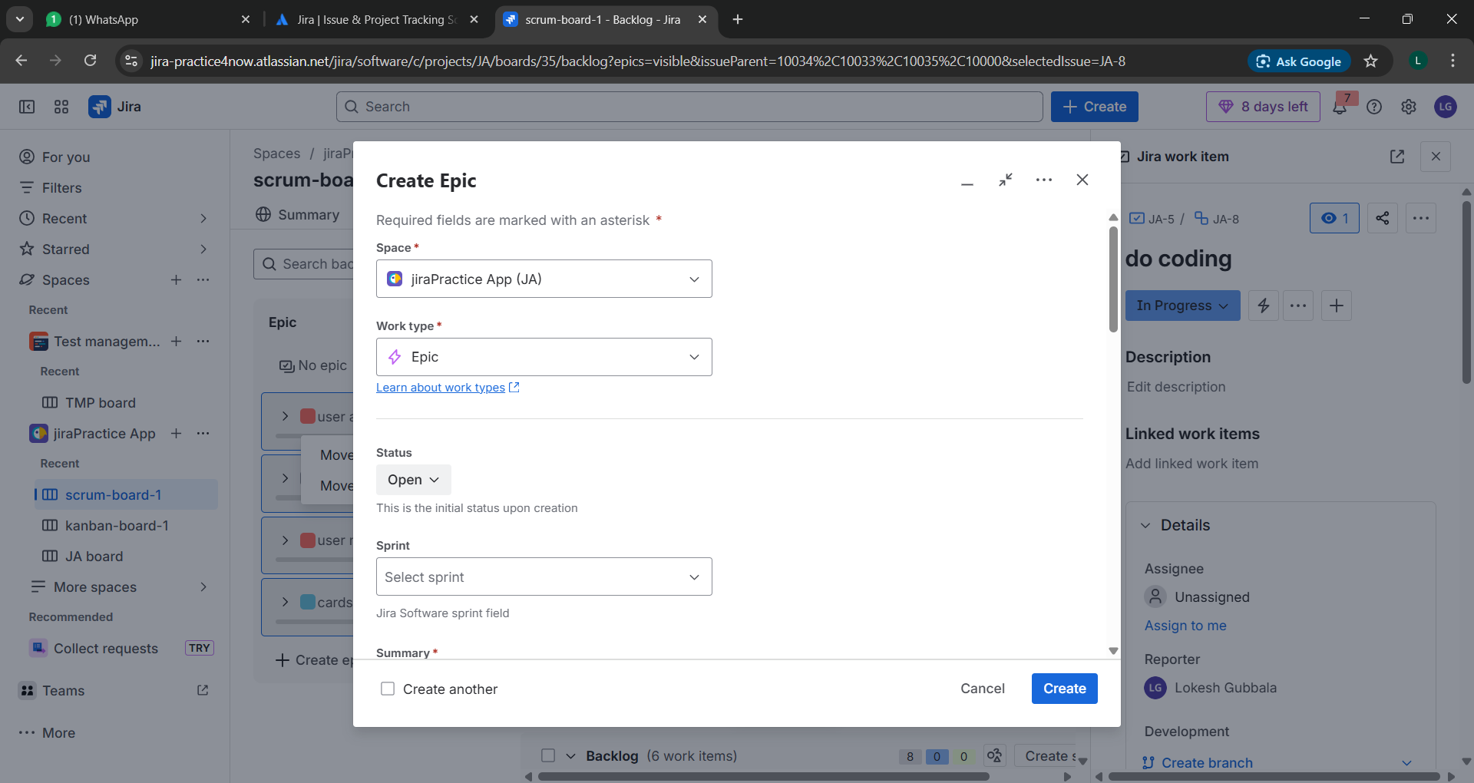

**7.creating a task**

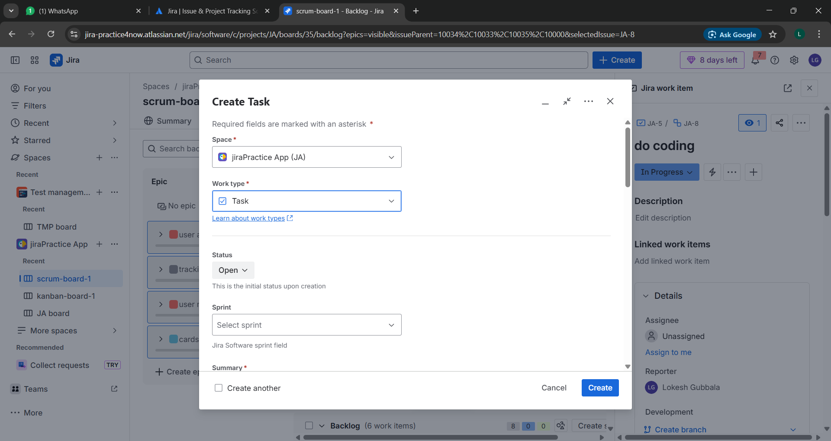

**8.creating a component**

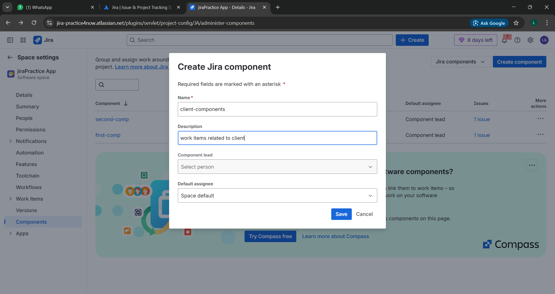

**9.creating a version**

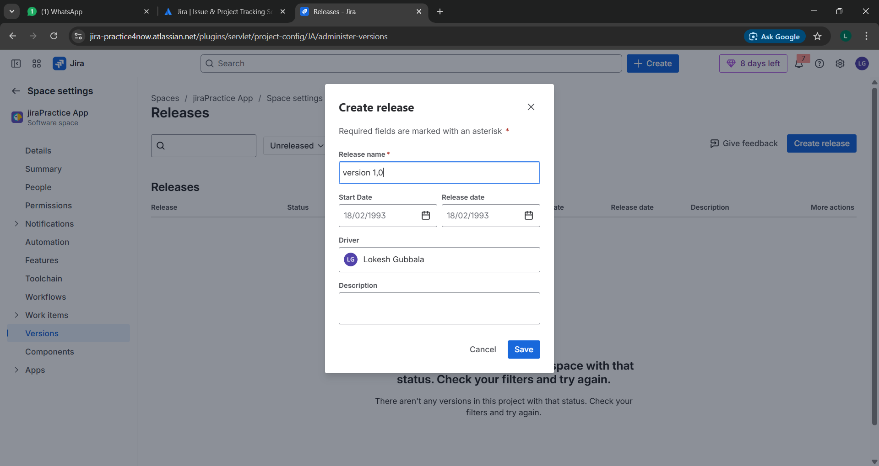

**10.linking an work items or adding dependence between work items**

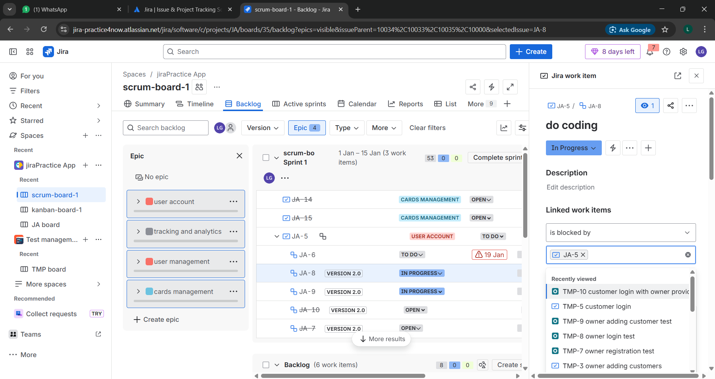

**11.editing a workflow**

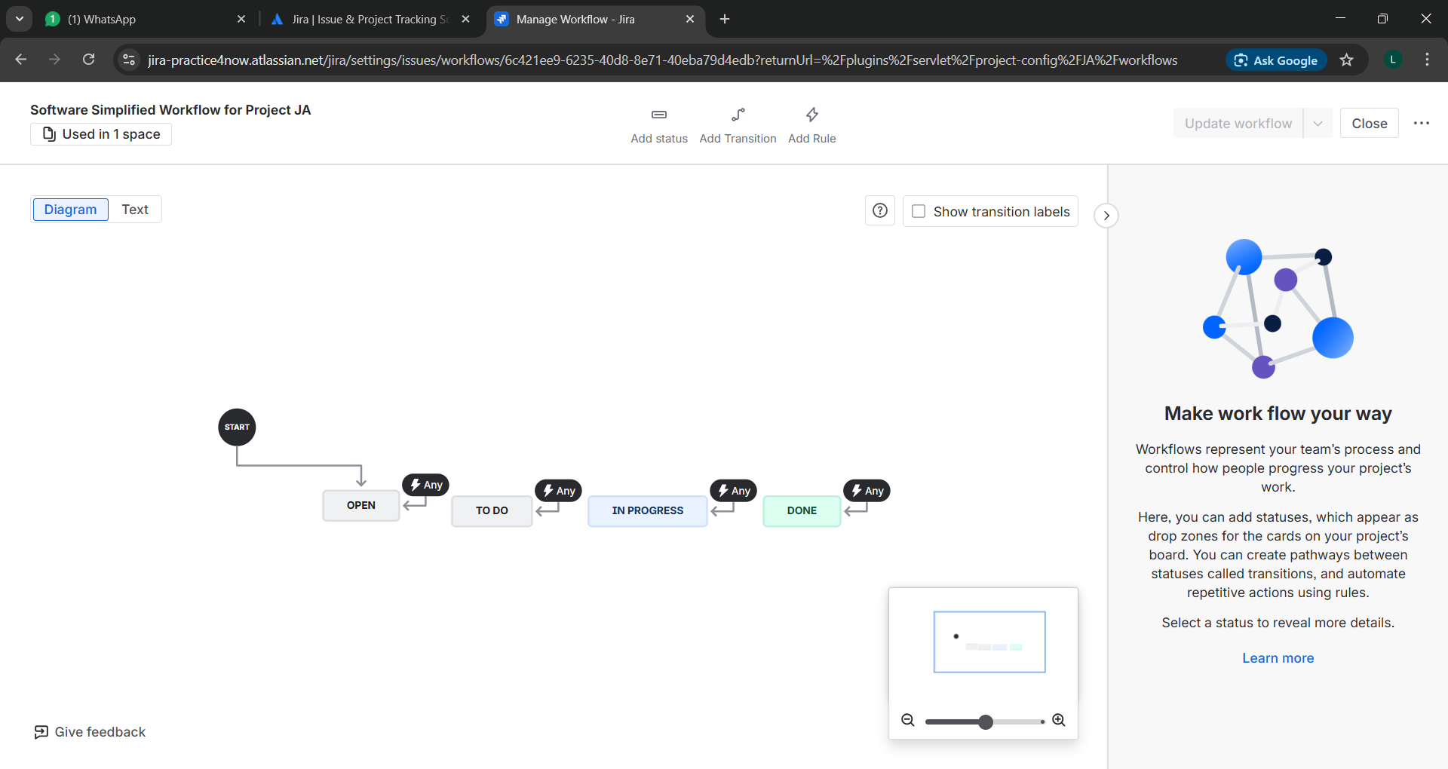

**12.creating a status**

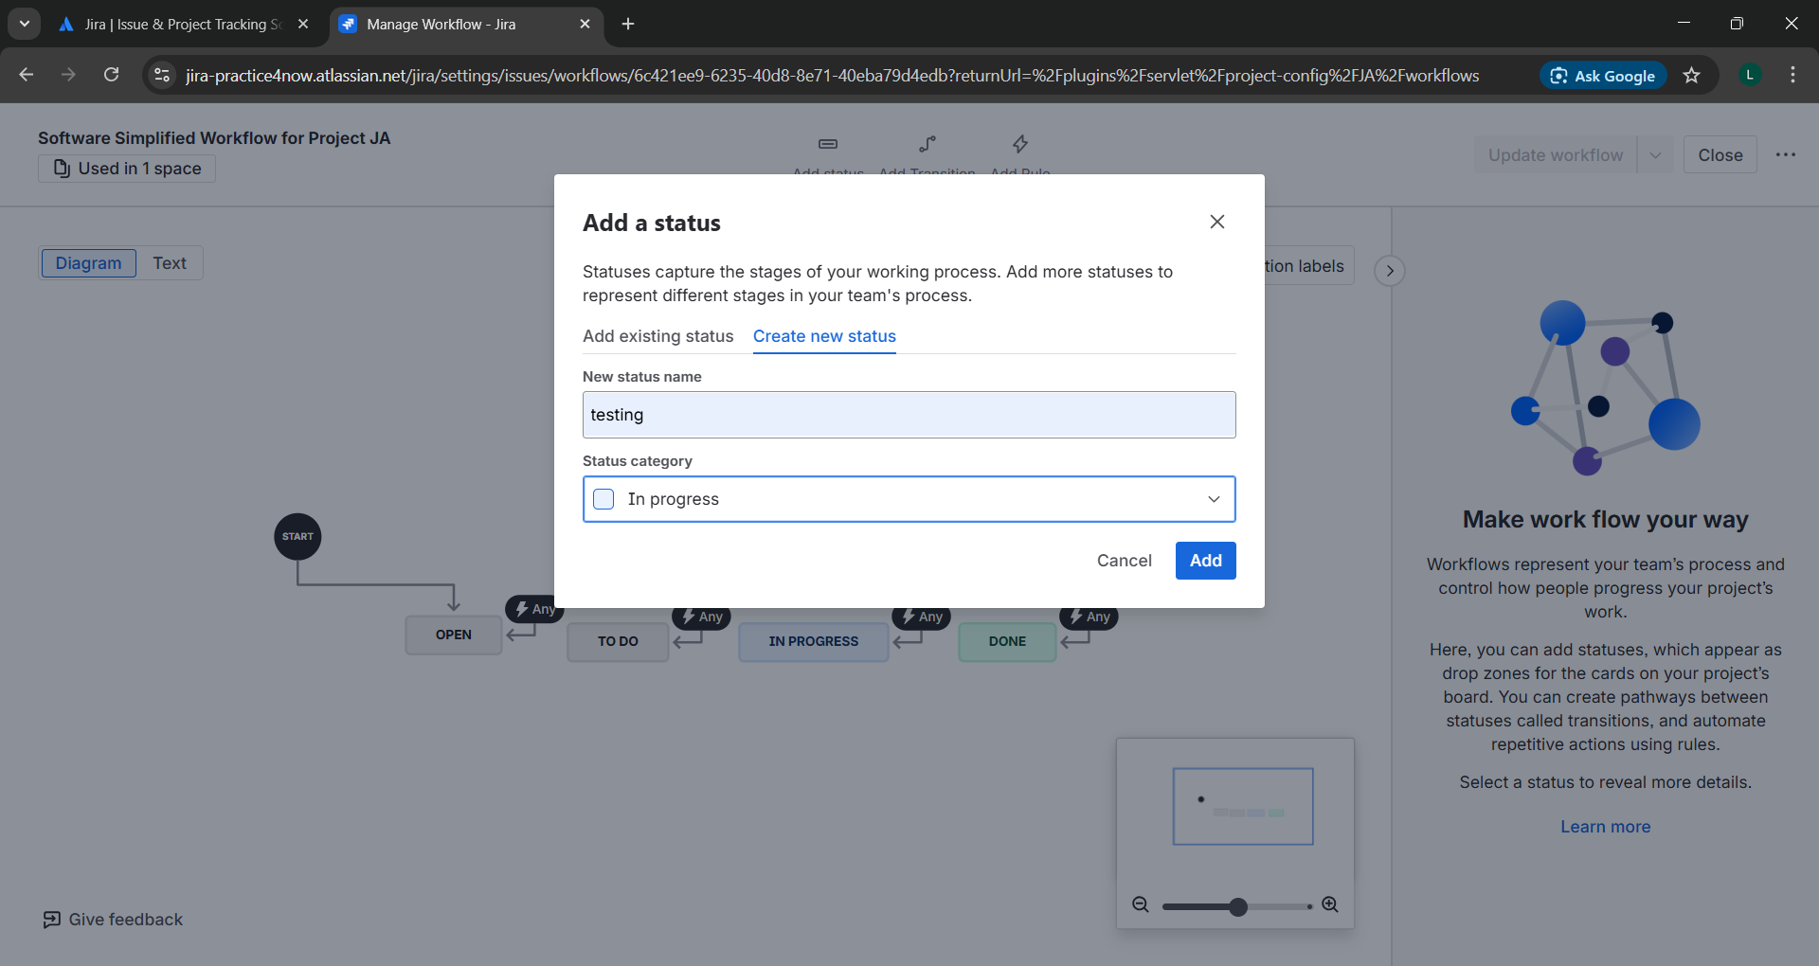

**13.Mapping the newly created status to one of the three categories such as to do,in progess,done**

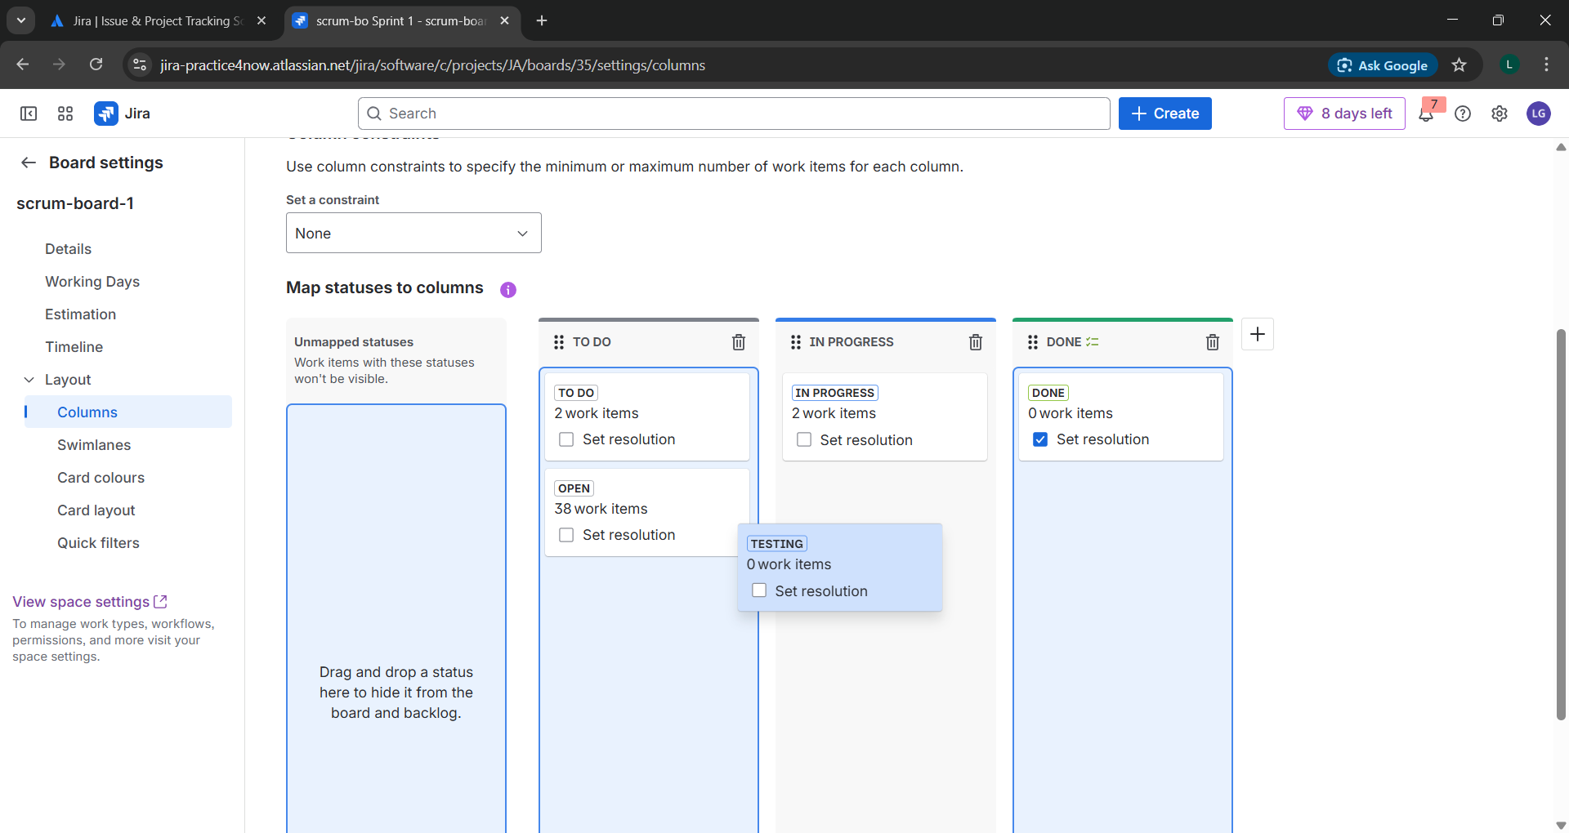

**14.JQL query based on status**

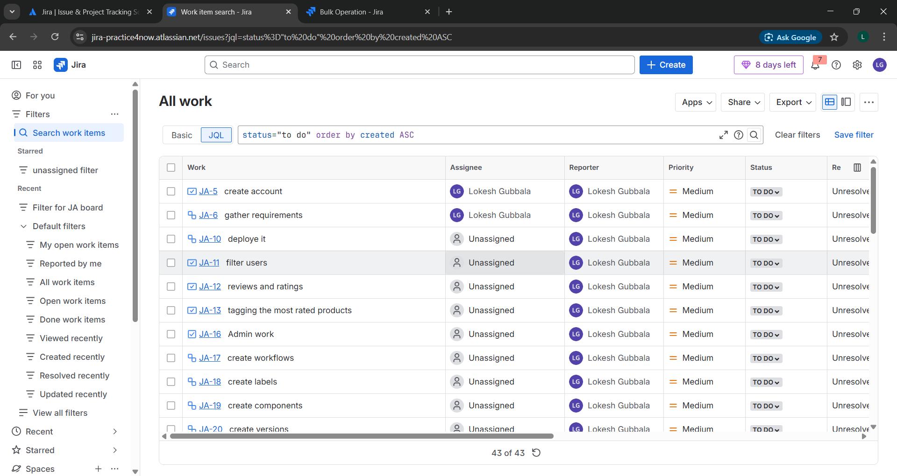

**15.JQL query based on day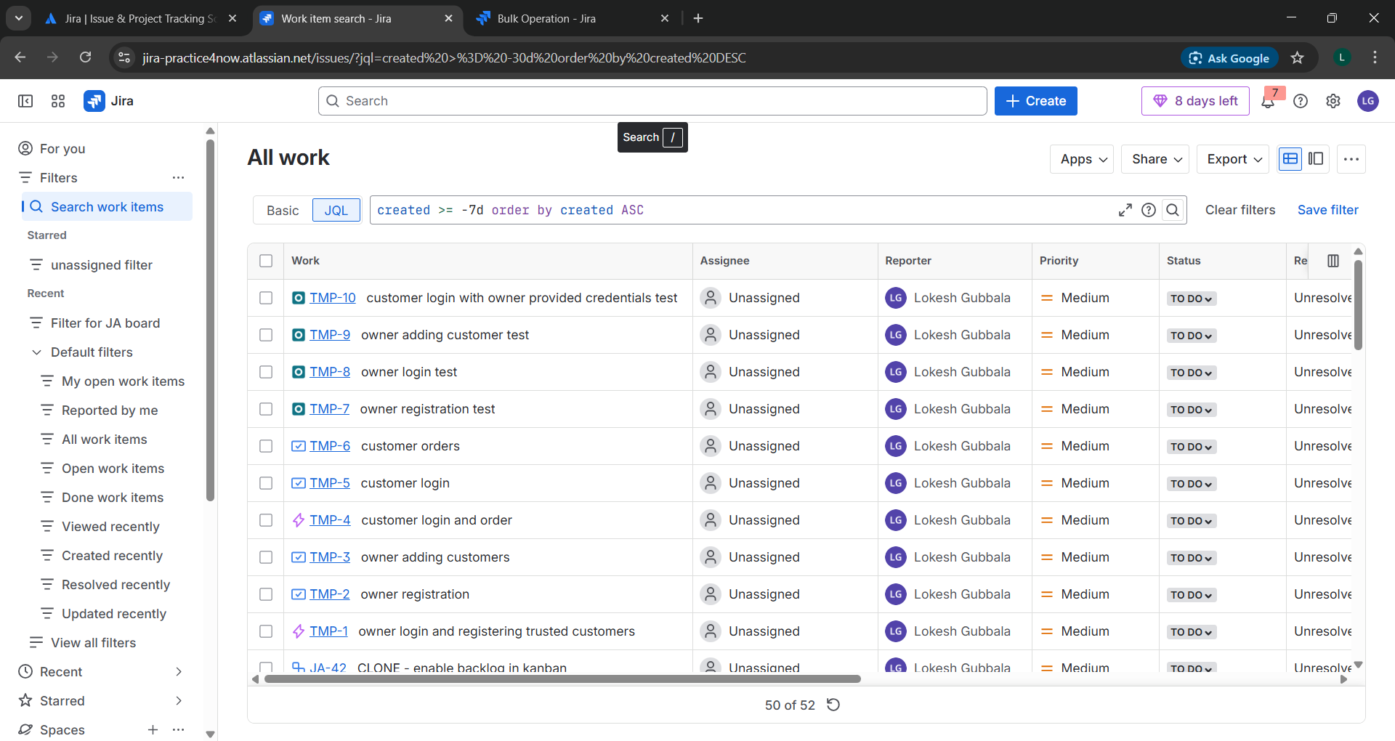s**

**16.Bulk operations using JQL**

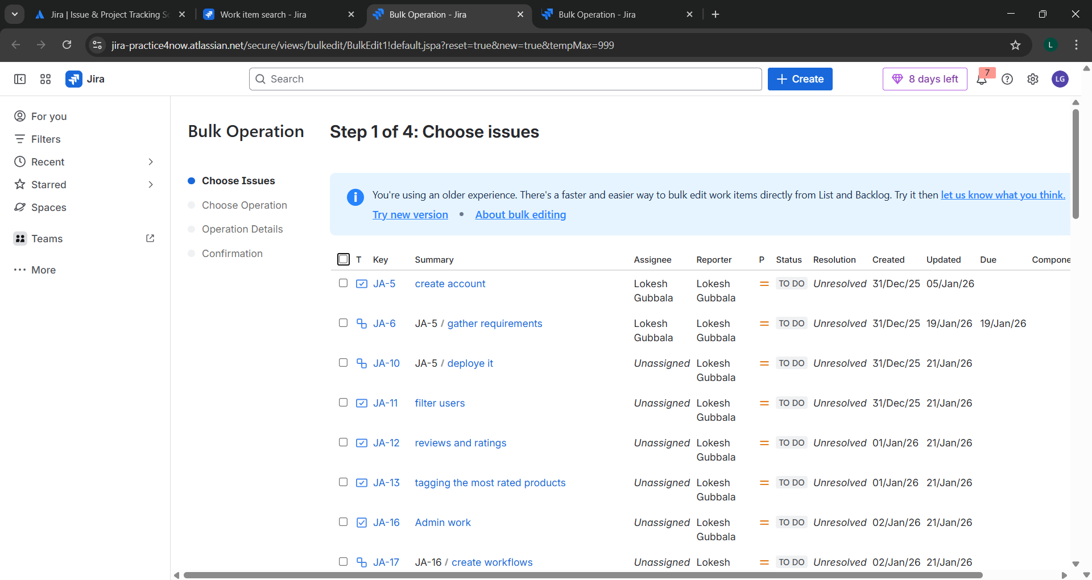

**17.Saving a filter**

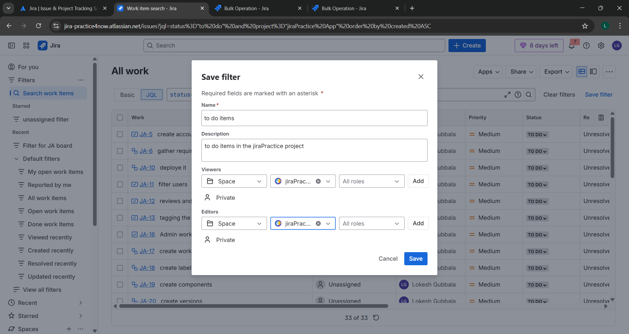

**18.Planning a sprint**

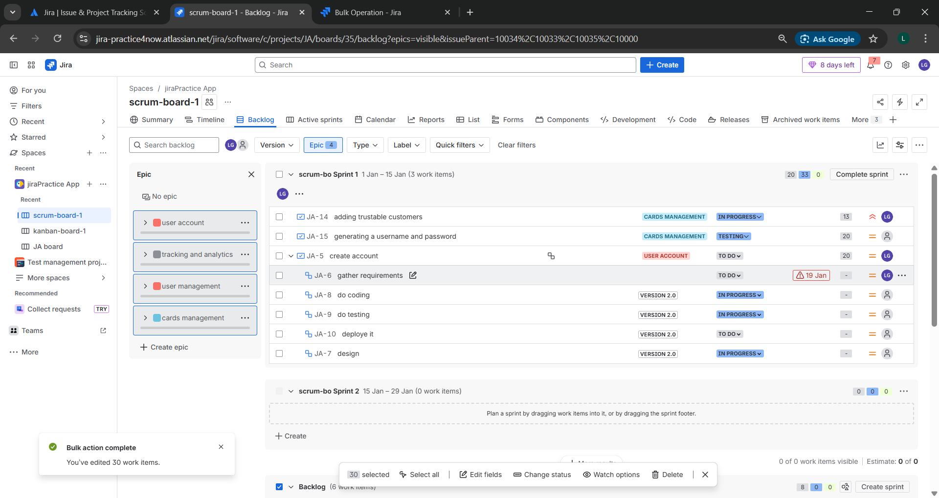

**19.creating Kanban board**

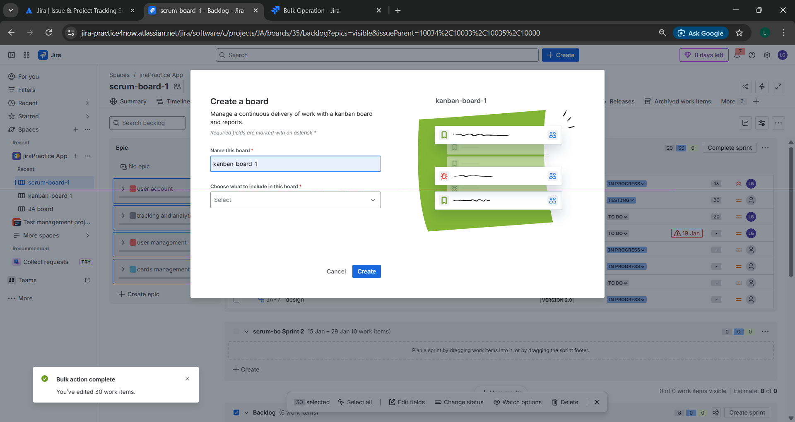

**20.enabling backlog in kanban board**

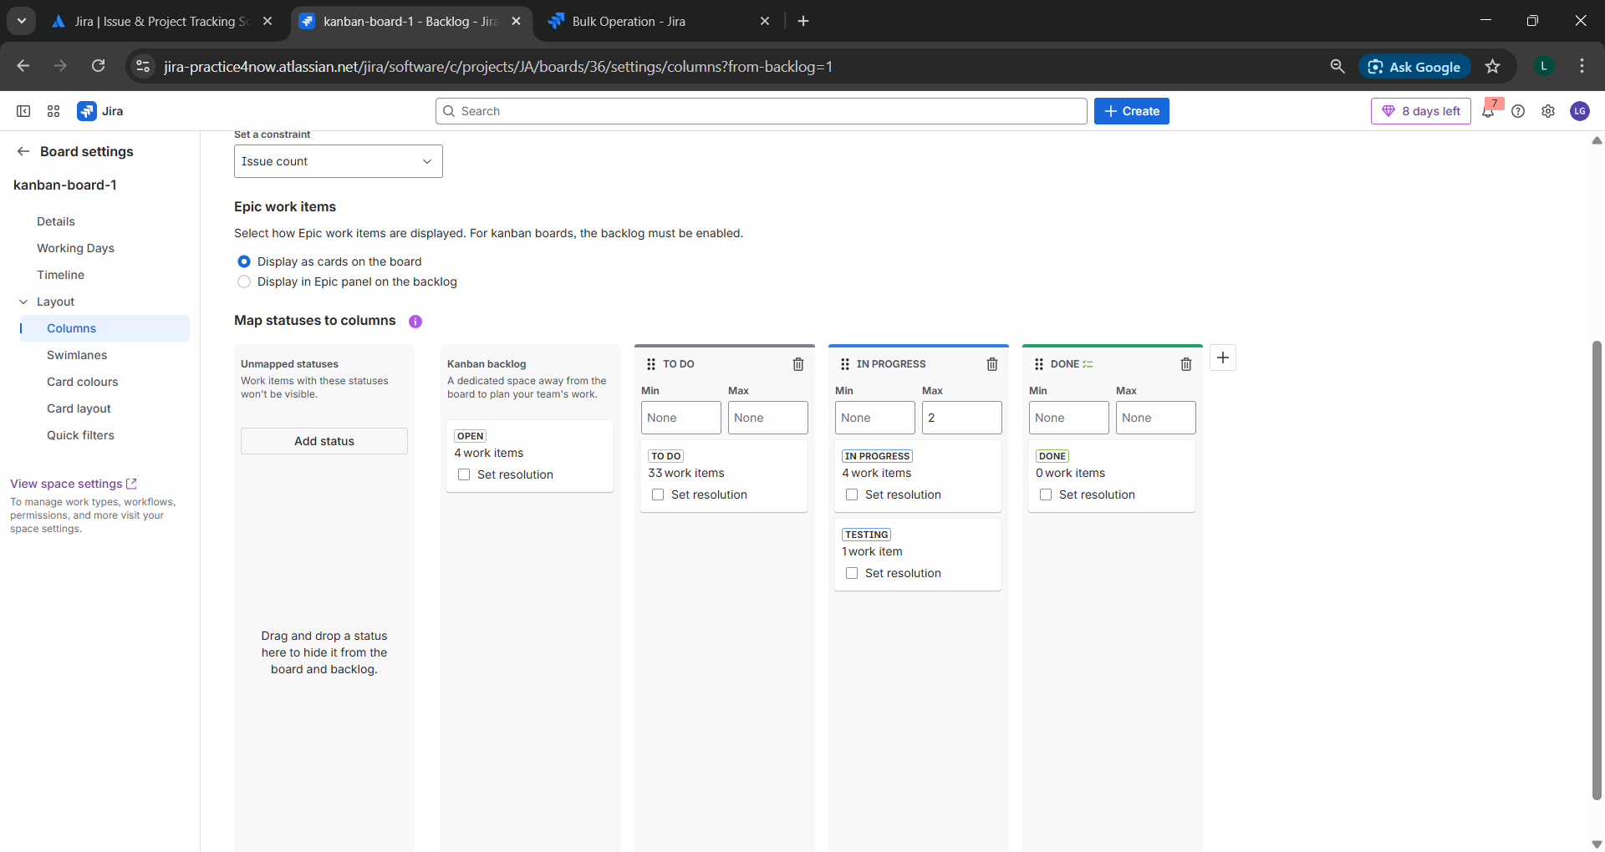

**21.Cummulative flow diagram for kanban**

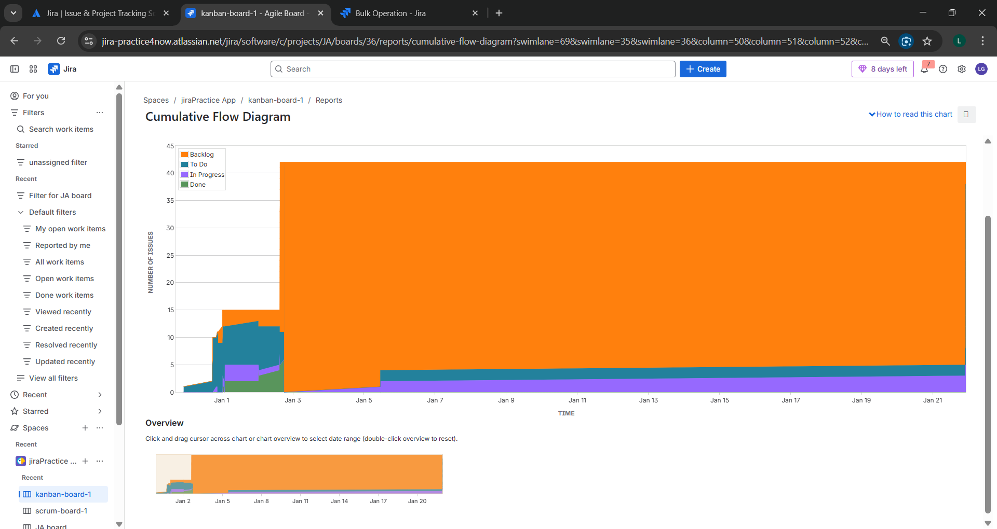

**22.creating a label and assign to multiple projects within the instance**

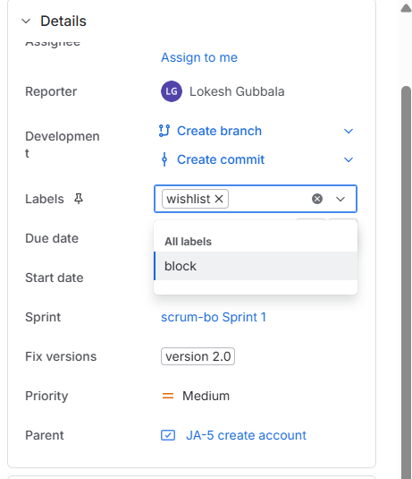

**23.setting WIP (work in progress) limit.**

